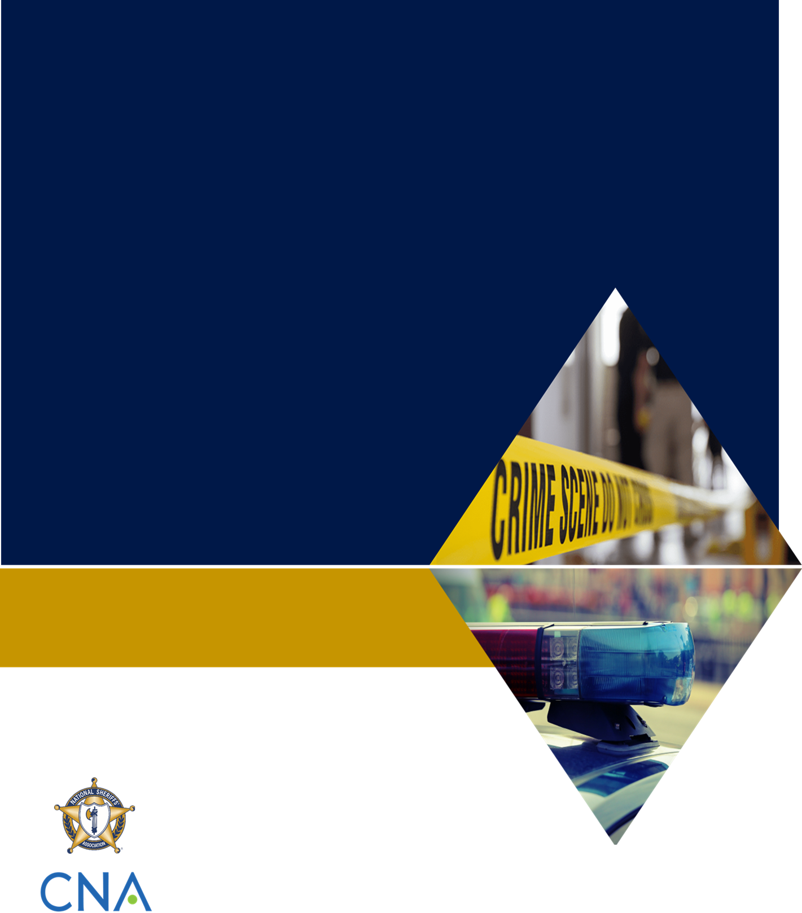
Table of Contents
[Insert Classification]
[Insert Name of Military Installation]
Active Shooter Response Tabletop Exercise
Participant Handbook

[Insert Date]
Insert your jurisdiction logo here
Table of Contents i
Handling Instructions iii
Section 1: Exercise Overview 1
Background 1
Exercise Objectives 1
Exercise Structure 1
Scenario 2
Module 1 3
Scenario 3
Discussion Questions 3
Module 2 4
Scenario 4
Discussion Questions 4
Module 3 6
Scenario 6
Discussion Questions 6

Handling Instructions
- The title of this document is the [Insert Name of Military Installation] Active Shooter Response Tabletop Exercise: Participant Handbook.
- Information gathered in this document is designated as [insert classification and handling instructions].
- For more information about the tabletop exercise (TTX), please consult the following point(s) of contact:
Name
Position
Agency/Organization
Contact information

Section 1: Exercise Overview

Background
Over the past 20 years, there have been more than 20 active shooter incidents on military installations. The most recent incidents, including the shootings at Pearl Harbor Naval Shipyard in Hawaii and Naval Air Station Pensacola in Florida in December 2019, have sparked conversation about the growing challenges involved in responding to active shooters on military installations. This TTX is designed to help military and civilian law enforcement agencies assess their preparedness for such incidents. Through guided questions, exercise participants will discuss their roles and responsibilities, communication and coordination processes, and tactical operations in response to a fictional active shooter scenario inspired by real events.

Exercise Objectives
Listed below are examples of exercise objectives. Add, remove, or modify objectives as needed to meet the needs of your jurisdiction.
- Provide a forum for agencies to communicate and collaborate on planning and response preparations for an active shooter incident on a military installation.
- Confirm the roles, responsibilities, lines of authority, and operations coordination of civilian law enforcement and military personnel during an active shooter incident on a military installation.
- Confirm proper channels for information sharing among civilian law enforcement and military personnel during an active shooter incident on a military installation.
- Confirm the process for coordinating public information and family reunification following an active shooter incident on a military installation.
- Identify any gaps in planning, policy, or response coordination that would hinder response efforts.

Exercise Structure
The discussion will be divided into three modules:
- Module 1: Planning
- Module 2: Immediate Incident Response
- Module 3: Post-Incident Response
At the start of each module, the facilitator will present key scenario events to provide a backdrop for the discussion. The facilitator will then pose discussion questions to help guide participants’ discussion. These questions are not meant to constitute a definitive list of issues, nor is there a requirement to address every question. Jurisdictional leadership and the facilitator will choose which questions to address in order to achieve the exercise objectives.

Scenario
The active shooter incident takes place at [insert name of military installation]. The scenario includes civilian and military agencies, including [insert names of relevant agencies]. Please note that the events described in the scenario are fictional and intended only for the purpose of participating in the exercise. The scenario does not take place under pandemic conditions. Further scenario details are provided in each of the following three modules.

Module 1

Scenario
[Insert name of military installation] hosts military personnel, contractors, and foreign nationals through the course of everyday work. On a typical Tuesday, [insert name of military installation law enforcement agency] deploys resources across the installation as usual. [Insert name of local law enforcement agency] officers patrol the community surrounding the installation, but are not present in the course of steady-state operations on the installation.

Discussion Questions

Operational Background
- What formal or informal agreements (e.g., memorandums of understanding or memorandums of agreement)/relationships do you have with the military installation within your jurisdiction?
- How familiar are you with the facility (e.g., the layout, procedures for access)?
- What is the level of collaboration between your organizations on a daily basis?
- Have you dealt with incidents at the military base in your jurisdiction before?
- Are you familiar with the base’s procedures regarding base access, foreign nationals, weapons, etc.?

Module 2

Scenario
At 1000 local time, while military personnel, contractors, and foreign nationals are present at [insert name of military installation], gunshots are heard throughout the base. A contractor armed with a handgun opens fire outside one of the administrative buildings within [insert name of military installation], wounding three adults before heading toward the commissary.
As the contractor continues to randomly open fire, he injures two more individuals. [Insert name of military installation law enforcement agency] quickly mobilizes and contacts the [insert name of local law enforcement agency] to send additional assistance.
At 1017, two deputies from the [insert name of local law enforcement agency] enter the base and encounter the assailant. The assailant fires at both officers, injuring one in the leg. After a brief engagement, one of the officers fires at the assailant, killing him on the scene.

Discussion Questions

Emergency Communications
- How do 9-1-1 operations and dispatch work?
- How will your agency receive notification and gain situational awareness of the incident?
- What reporting tools, if any, will the responding sheriff’s office use to communicate critical information to supporting agencies?
- What are the thresholds or triggers for requesting additional assistance from surrounding counties?
- Are there any policy gaps or functions that might impede or impact civilian agencies’ response efforts?

Base Access and Incident/Unified Command
- Are you familiar with the “lockdown” procedures on the base in your jurisdiction?
- Do you anticipate that civilian responders will have issues accessing the base’s buildings?
- What personnel will provide real-time directions/instructions for access?
- Will you establish a unified command?

Tactical Operations
- How will the tactical police response be organized/managed?
- What are the active shooter protocols of the responding sheriff’s office?
- Do you have joint police-EMS protocols?
- How will EMS operations be organized and managed?
- What challenges might have been encountered if the incident had occurred at another time of day or week (e.g., at nighttime or on a workday)?

Module 3

Scenario
By 1100, civilian and military law enforcement agencies have completely evacuated [insert name of military installation]. EMS personnel have arrived to assess the scene and treat the injured individuals.
According to reports, there are four injured individuals and two deaths. Local EMS providers transport the victims to the nearest hospital for treatment.
Reports of the incident quickly circulate among social media sites as well as local and national news networks. Concerned family members begin contacting local and [insert name of military installation] authorities for answers regarding their loved ones.

Discussion Questions

Public Information and Family Reunification
- What agency will be responsible for communicating with the public?
- What are the processes for coordinating victim assistance and family reunification services?

